Database Module 3 No 4, 7, 9

Name: Bryan Orville Audric

NIM: 2602160750

No 4

Add a constraint named “check_phonenumber” to check the CustomerPhone must be numeric.

ALTER TABLE mscustomer ADD CONSTRAINT check_phonenumber CHECK (mscustomer.CustomerPhone REGEXP '^\d*')

No 7

Update data on MsCustomer table by adding ‘Mrs.’ to customer name and adding ‘lady’ to customer email before the ‘@’ character for every female customer which age is over 20.

(CONCAT, INSERT, LOCATE, TIMESTAMPDIFF, CURDATE)

UPDATE mscustomer

SET mscustomer.CustomerName = CONCAT('Mrs.',mscustomer.CustomerName),

mscustomer.CustomerEmail =INSERT(mscustomer.CustomerEmail, LOCATE('@',mscustomer.CustomerEmail),0,'lady')

WHERE mscustomer.CustomerGender = 'Female' AND TIMESTAMPDIFF(YEAR,mscustomer.CustomerDOB,CURRENT_DATE())>20

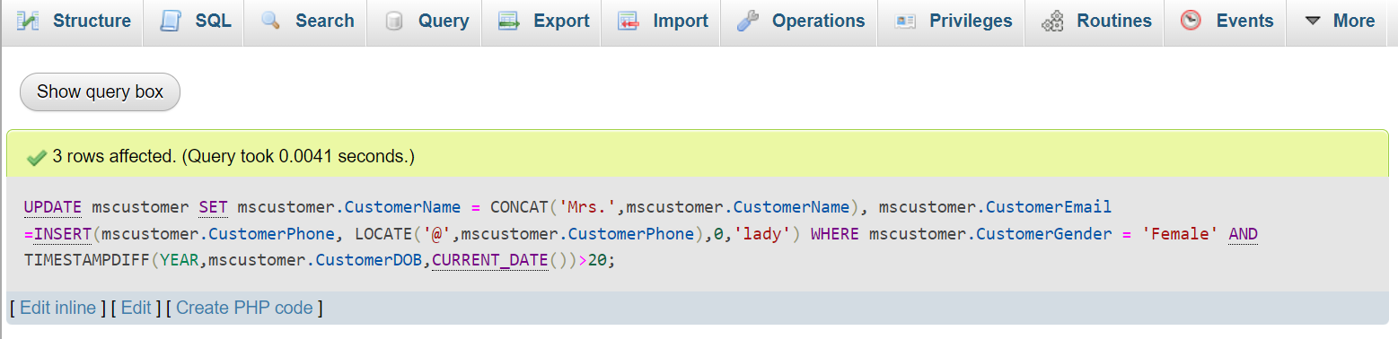

After Update:

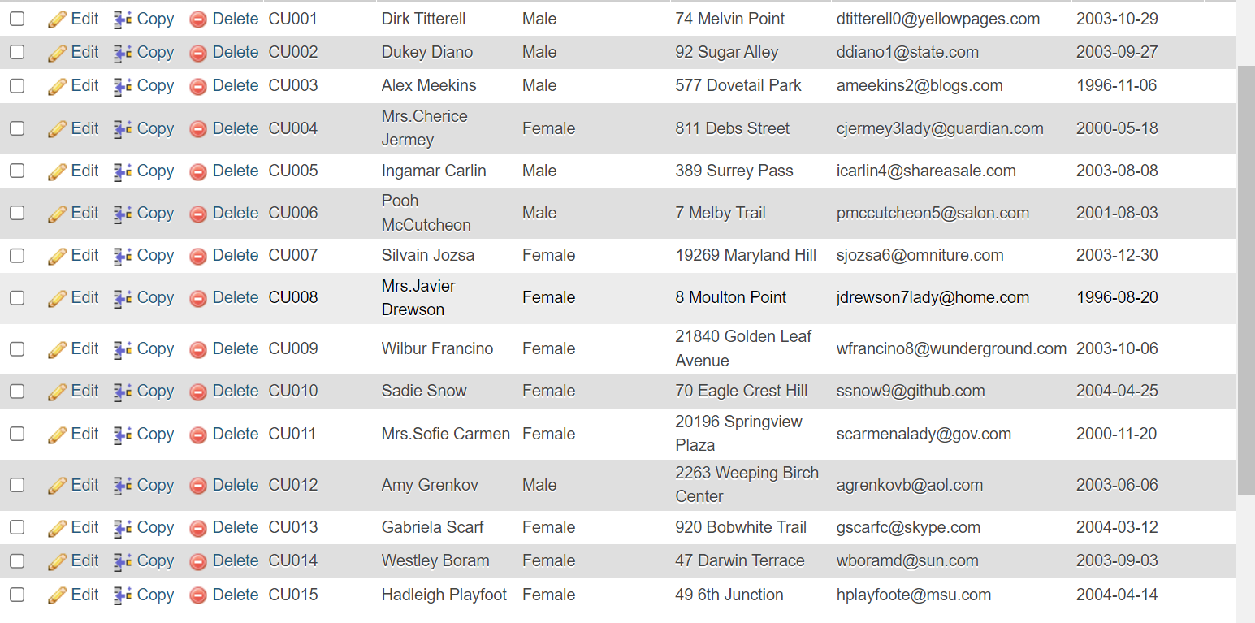

No 9

Display EmployeeName and EmployeeAddress for every employee who ever handled a transaction with a female customer in December.

(DISTINCT, MONTH)

SELECT DISTINCT(msemployee.EmployeeName) AS 'EmployeeName', msemployee.EmployeeAddress

FROM msemployee INNER JOIN transactionheader ON msemployee.EmployeeID = transactionheader.EmployeeID INNER JOIN mscustomer ON transactionheader.CustomerID = mscustomer.CustomerID

WHERE mscustomer.CustomerGender = 'Female' AND MONTH(transactionheader.TransactionDate) = 12

